**DolphinGroup**

A project collaborator hunting space

BindUP

ABOUT PROJECT

# Project Introduction

## Context

Start-up, entrepreneurship, innovation, and creativity are buzzwords that are becoming increasingly trendy and appealing as the world changes around us and new technologies are produced and discovered to improve our lives and usher us into a more modern era. Young intellectuals and entrepreneurs therefore play a crucial role in transferring and spreading the inspiration of creativity as well as the spirit of entrepreneurship across society. This innovative spirit is manifested specifically through startup projects, new products, ideas from competition or shared on social networking sites. Especially university students are highly creative people and must do a lot of group projects not only in school but also in extracurricular activities. Anyone, not just students or innovators, can have an idea about some change-making technologies/tools, no matter what it is a prototype, a launching product, or upcoming one. They want to share their works to get more feedback and be judged by a dedicated community. Maybe they will need to find a partner to collaborate with on a project or a mentor but the connection between parties in the innovation fields is quite loose. On the other hand, many individuals who want to find a perfect team matching their needs and wants but their network is not qualified enough to satisfy. Angel investors want to find new ideas, products with potential for development to support and accompany, but have to search from many different sources such as newspapers, social networks or relationships.

## Problems

* FPT students have difficulties in finding project teams for some subjects (EXE, SWP, 9th-term project...).
* FPT students have startup ideas but do not have a suitable platform to introduce themselves and recruit team members and find investment sources.
* FPT students lack a community to exchange knowledge, experiences, and startup experiences.
* FPT students face difficulties in finding end-of-term project instructors or mentors for startups.
* The high competitiveness in the market makes it difficult for FPT students to compete with experienced entrepreneurs and find potential customers for their startups.

## Proposed solutions

On this platform, students can receive some benefits to help them overcome the challenges they faced previously:

* Improved access to resources: By introducing their products on the platform, students can improve their chances of attracting potential investors...
* Ease in finding mentors and personnel: The platform also provides features to support the search for human resources for the project and ways to communicate with mentors.
* Increased networking opportunities: The platform provides a community for sharing experiences and insights from experienced startup professionals.
* Enhancing visibility and exposure of the students' products: The platform helps students introduce their products to potential investors and customers. It helps reduce the competition with experienced entrepreneurs on the market.

By using the resources provided by the platform, students starting a startup can overcome many challenges they faced before and achieve greater success in their business project.

# Project specification

## Main actors

* Guest
* User
* Admin

## Features

**Guest:**

* Sign up/Log in
* View project
* View project’s details
* Search project
* Search user
* View user’s profile

**User:**

* Login
* Manage user’s profile (View, Edit)
* Reset, change password
* Get notifications
* Manage application (Create, View, Edit, Cancel)
* Upvote/Downvote a project
* View list of upvoting/downvoting project

**Founder / Leader:**

* Log in
* Manage project (Create, View, Edit, Delete)
* Manage project detail (Create, View, Edit, Delete)
* Manage project’s changelog (Create, View, Edit, Delete)
* Add members, mentors for the project
* View, approve/reject applications

**Admin:**

* Log in
* Manage project (View, Remove)
* Manage user (Create, View, Update, Delete)
* Manage topic (Create, View, Update, Delete)

**System**:

* Notify when a new user applies to a project
* Notify all users in the project when the project changes

## Business rules

1. Users can sign in using username and password or using gmail.
2. The minimum length of username is 6, and the maximum length is 20. Username can only contain alphabetical characters and numbers.
3. The minimum length of password is 6, and the maximum length is 20. Password can contain any characters except blank.
4. Each account is linked to one user only.
5. Users must have name, gender, email and phone must be filled.
6. Users’ gender can be man or woman. In the database, man is saved as number 0, and woman is saved as number 1.
7. User’s name should have at least 10 characters and at most 50 characters.
8. The user’s headline should have at most 100 characters. It can contain only alphabetical and blank characters.
9. User’s description should have at most 512 characters. It can contain only alphabetical, numerical and blank characters.
10. User’s address should have at most 512 characters. It can contain only alphabetical, numerical and blank characters.
11. User’s phone number should have at most 20 characters and cannot be duplicated. It can only contain numerical characters.
12. A user’s email should have at most 50 characters and cannot be duplicated.
13. Each user can have at least 1 and at most 5 majors.
14. Each major can be obtained by unlimited users.
15. The Major’s description should have at most 512 characters. It can contain only alphabetical, numerical and blank characters.
16. Users can only have 1 active application per project.
17. Each application belongs to one project only.
18. Each application contains only one job.
19. Application’s description should have at most 512 characters. It can contain only alphabetical, numerical and blank characters.
20. Application can only have 3 statuses: pending as number 0, accepted as number 1 and rejected as number 2. Only pending applications count as active ones.
21. Each job belongs to one project only.
22. Job’s name should have at least 1 character and at most 100 characters. It can contain only alphabetical and blank characters.
23. Project’s name should be at least 6 characters and at most 100 characters. It can contain only alphabetical, numerical and blank characters.
24. Project’s summary should have at least 30 characters and at most 512 characters. It can contain only alphabetical, numerical and blank characters. It can contain only alphabetical, numerical and blank characters.
25. Project’s description should have at least 30 characters and at most 512 characters. It can contain only alphabetical, numerical and blank characters.
26. Project’s milestone varies from 0 to 5. Each milestone’s name is in order: Closed, Concept, Design, Prototype, Completed and Launched.
27. Each project can have at most 10 images (logo not included).
28. Each project can only have one logo.
29. Each project can only have one source.
30. Each project should have at least 1 member.
31. Each member can only belong to 1 project.
32. Each project member can only have 1 role.
33. Each project member can only have 1 title.
34. Each user can only vote on a project once.
35. Each project can have at most 3 mentors.
36. Each mentor can only guide at most 3 projects.
37. Mentor’s name should have at least 1 character and at most 50 characters. It can contain only alphabetical and blank characters.
38. A mentor’s major should have at least 1 character and at most 50 characters. It can contain only alphabetical and blank characters.
39. A mentor’s phone should have at most 20 characters and cannot be duplicated. It can contain only numerical characters.

Mentor’s email should have at most 20 characters and cannot be duplicated.

1. Each project should have at most 10 topics.
2. Each topic’s name should have at least 1 character and at most 50 characters. It also cannot be duplicated. It can contain only alphabetical blank characters.
3. Each topic’s description should have at least 30 characters and at most 512 characters. It can contain only alphabetical, numerical and blank characters.
4. Each topic’s short name should have at least 1 character and at most 50 characters. It also cannot be duplicated. It can contain only alphabetical characters.
5. Each project can have at most 50 changelogs.
6. Each changelog can only belong to 1 project.
7. Changelog’s description should have at least 30 characters and at most 512 characters. It can contain only alphabetical, numerical and blank characters.
8. Changelog’s title should have at least 10 characters and at most 512 characters. It can contain only alphabetical, numerical and blank characters.

## Database

### Conceptual

### Logical

### Physical

## System overview diagram

## Link: <https://app.diagrams.net/#G1JuO8VJzB5xqc7pAaTSjkkiowzdLf1v91>

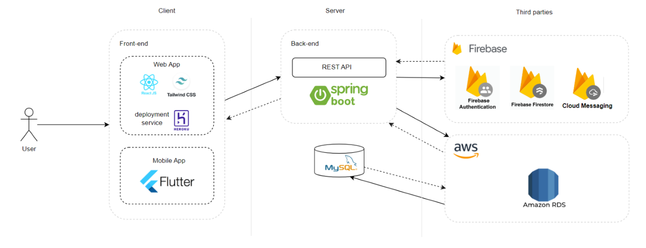

## Mobile screen list

* Home (List Product)
* Project view details
* Overview
* Milestones
* Member
* User
* Change logs
* Application
* My Project
* Team Project
* Owner Project
* Create Project
* Notifications
* Account
* Login
* Register
* Edit Account
* Application
* Change Password

## Screen Map

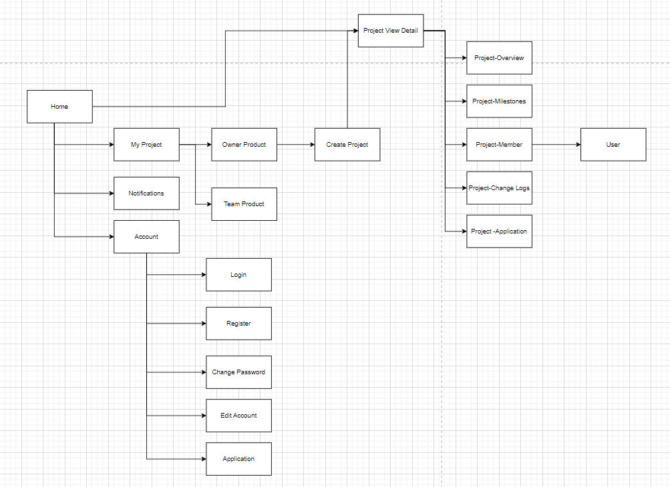

# References

**Database Link:**    
mysql-db.cpzqgswgt4xf.ap-southeast-1.rds.amazonaws.com:3306/fpt-prodhunt-db

**GitHub BE link:**   
<https://github.com/KhangNV0701/FPTBindUpBE>

**GitHub FE link:**   
<https://github.com/kabutoshinki/FPTBindUpFE>

**Deploy FE link:**   
<https://dashboard-heroku.herokuapp.com/>

**GitHub Mobile link:**   
<https://github.com/huylt-orca/FPTBindUpAndroid>

**Mobile Figma:**

<https://www.figma.com/file/s6RIGAOE6QRHPgHsBUbMe0/ProductZone---Mobile-design?t=fmMDJt3qdIceFMUT-1>

**Deploy Swagger link:**   
<http://fhunt-env.eba-pr2amuxm.ap-southeast-1.elasticbeanstalk.com/swagger-ui/index.html>